**AI IS KNOWLEDGE**

**MACHINE LEARNING** learning thinking capabilities of humans, - recommendation of Amazon

Deep learning of the human brain

GEN AI - TYPE DEEP LEARNING

DIFFERENT WITH MACHINE LEARNING - Machines that emulate short term memory

AI ES DE BIGGEST UMBRELLA

Ai

DATA SCIENTIST – Value of the data and the uses of all of the AI

Apply

AI TYPE

ARTIFICIALL NERROW INTELLIGENCE (ANI)

Drive a car, is just doing A THING

One thing only

ANI Take all data from the past next AI identify trends, and project the future PREDICTIVE ANALYTICIS

PRESTRICTIVE – If we change the values what could have

SUPERVICE -

UNSUPERVICE

JUST ONE THING, JUST ONE PROBLEM.

ARTIFFIVIAL GENERAL INTELLIGENCE ( AGI) BRAND NEW GPTS

emulation of all the captabilities of the human.

ARTIFFICAL SUPER INTELLIGENCE

AI write code to make it self better.

AI DOES IS JUST TRANFORMATION

Input Output

Matriz function Matrix prediction

AI

IDENTIFY PATTERS

Narrow they identify the patters

And then make a prediction

Just keep the data in and the more the data que you prove the better going to get

Learning patterns

Stockmarket – Data will predict

And will be accurate

DECISION – CONTRUBUTES MEMBERS TO DECISIONS

Patterns more layers more patters

Pixels Edges of the pictures Pictures nose or body

AI understand the empathy and the feeling of the humans

AI IS DIGESTING EVERYTHING THAT IS AROUND LIKE BOOKS, ARTICLES,

AGI cross the line

Peolple implement Business

Understand habilies human tasks

AGI BRINGS TO THE ALLIGMENT

AI APPS

Together.AI

Llamacoder.togetherai

**CLASS 2**

Advantage of the use cases and most of cases

AI is 3 separate ideas

Narrow AI – one thing pretty well – doing just one

Ai is cheap is free, value is the data.

DATA - is the most valuable resource nowadays

GENERAL AI – ai that does lot of things

AI

ANI

AGI

ASI

**MACHINE LEARNING** – DOES NOT EXIST WITHOUT DATA

AI IS BASED ON DATA, HISTORICAL

Now google inventent BIG DATA

Google gonna SHORT mean that the data the machines will

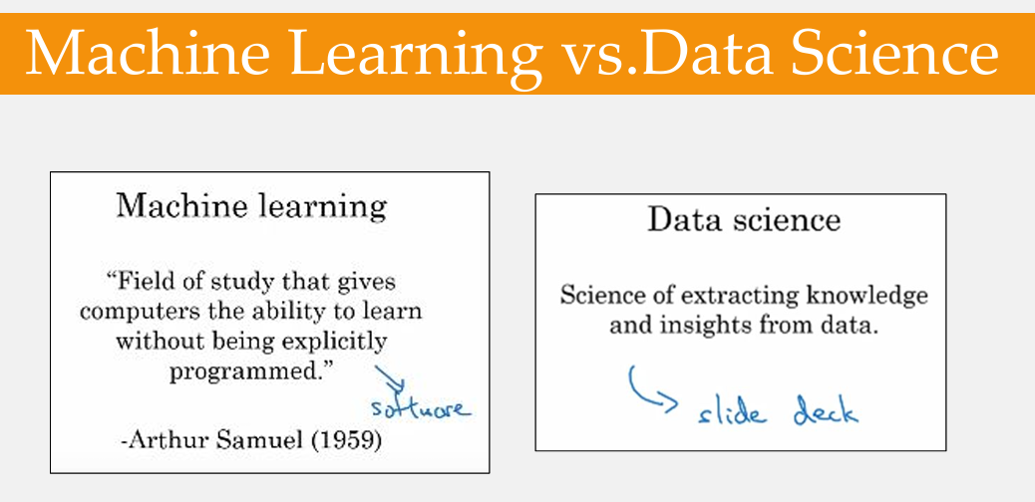

Machine learning floks – Code, Algorithm

They don’t have deep industry experience – they don’t know how to generate valuable

DATA SCIENTST COVER ALL OH THOSE PARTS

Example: Amazon do everything that internet allow us to do in a better way